User Guide of Faculty Center
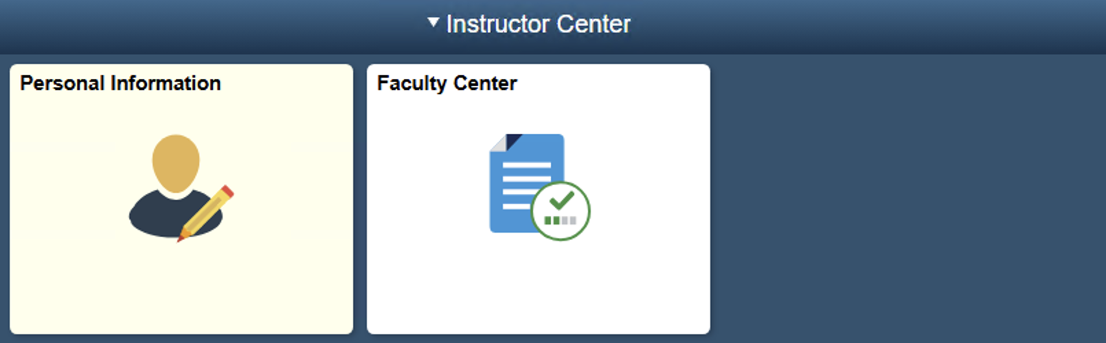
User guide of the PeopleSoft system for faculties and supervisors.

Author | Drafted by | Revised by | Approved by
Name | 燕婷婷 | 顾云哲 | 陈琪

Document History
Version | Date | Comments
1.0 | 2025.4.30 | Initial Version
2.0 | 2025.9.30 | Update of Graduation Project module contents

Contents
1. Overview of the Manual 3
2. System Login 4
3. Viewing and Maintaining Personal Information 7
3.1 Viewing personal data summary 8
3.2 Viewing names 9
3.3 Maintaining addresses 10
3.4 Maintaining email addresses 10
3.5 Maintaining emergency contacts 11
3.6 Viewing demographic information 14
4. Viewing Teaching and Exam Schedules, Class Roster and Grade Roster 15
4.1 Viewing teaching and exam schedules 16
4.2 Viewing class roster 27
4.3 Viewing grade roster 32
5. Graduation Project 37
5.1 Submit projects 38
5.2 Select my students 41
5.3 View my students 42
6. Viewing Evaluation Results Summary 44

- Overview of the Manual
This manual aims to help teachers in the campus become familiar with the functional modules and common operations of the PeopleSoft faculty center, so that they can efficiently participate in the daily teaching activities of the campus. The functions of the PeopleSoft faculty center are divided into two major parts: "Personal Information" and "Faculty Center". "Personal Information" is used to view and maintain teachers' commonly used basic personal information, such as email addresses, emergency contacts, etc. The "Faculty Center" is the core business module. Teachers can view the course information they teach each semester, participate in the submission of graduation design topics and Counter-selection of students' voluntary choices, and view their own teaching evaluation results.

- System Login
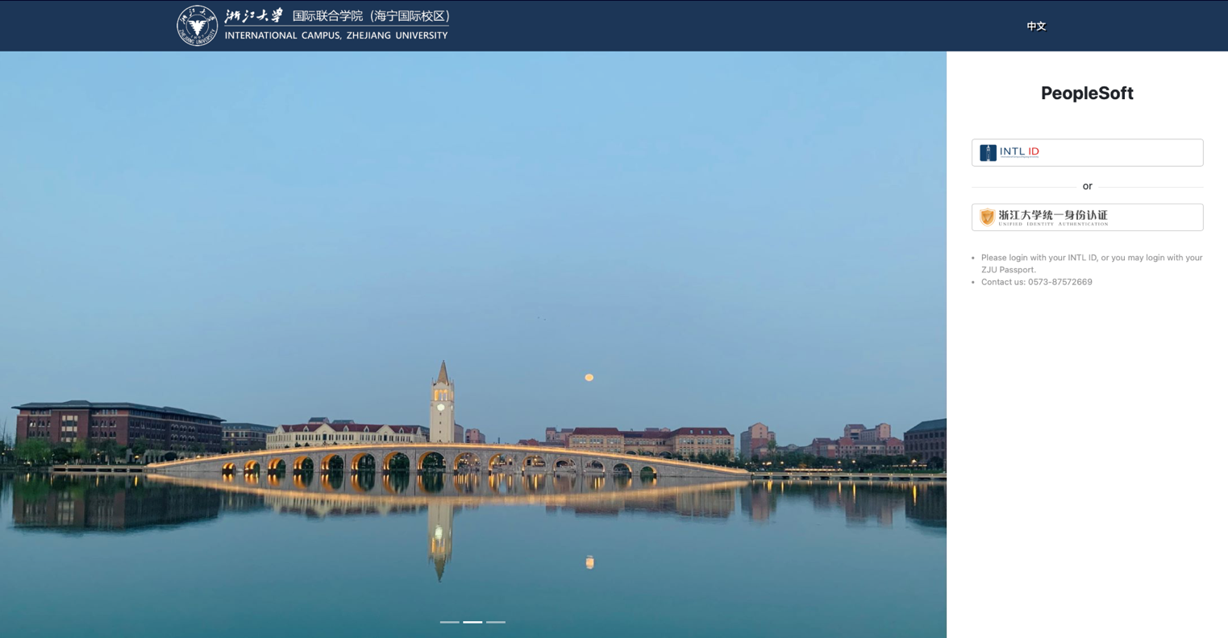
Visit https://scrsprd.zju.edu.cn/, or enter the official website of the International Campus, Zhejiang University at https://www.intl.zju.edu.cn. Click on "Faculty & Staff" in the upper right corner, and then click on PeopleSoft to open the PeopleSoft login page.
Figure 1: System Login – English Environment

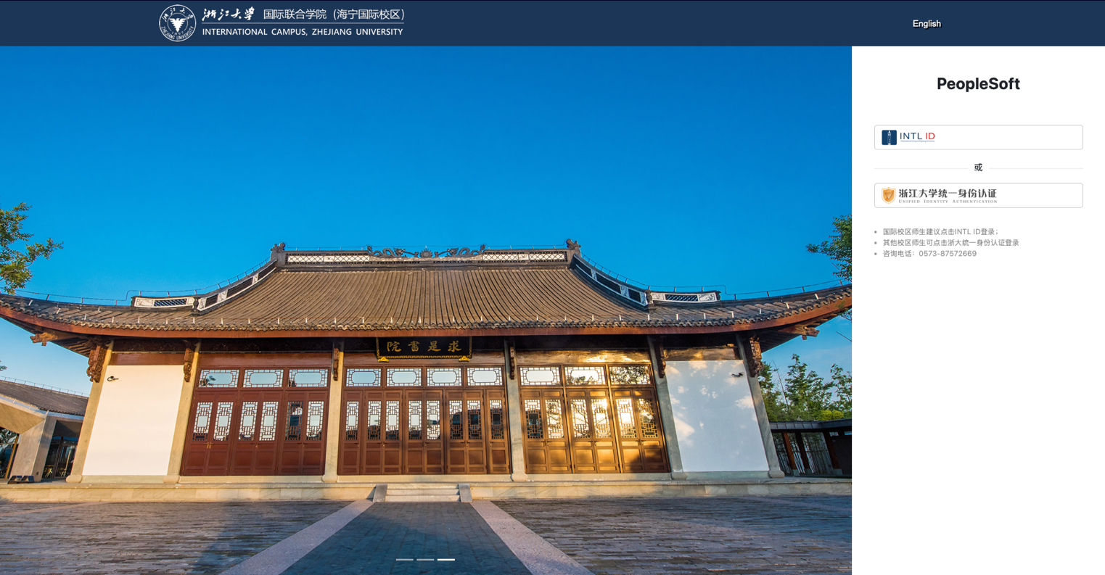
Figure 2: System Login – Chinese Environment
There are two login methods: You can log in to the system through the INTL ID unified identity authentication or the unified identity authentication of Zhejiang University.
- When using the INTL ID unified identity authentication, you can switch the system language through the link in the upper right corner. When the link in the upper right corner displays "中文", the instruction text below the login button is in English. At this time, clicking the INTL ID button will log you into the English environment. Clicking the "中文" link in the upper right corner is used to switch to the Chinese language. After the switch, the link in the upper right corner will display "English", and the instruction text below the login button will change to Chinese. At this time, clicking the INTL ID button will log you into the Chinese environment.
- When using the unified identity authentication of Zhejiang University, you can only log in to the English environment.
Figure 3: After Logging in – System Home Page
PeopleSoft supports access via mainstream browsers, such as Google Chrome (minimum version is Chrome 69), Mozilla Firefox (minimum version is Firefox 62), Microsoft Edge (minimum version is Edge 42+), Apple Safari (minimum version is Safari 12), etc. It is recommended to upgrade your browser to the latest version. It is not recommended to access PeopleSoft on the Linux system, as there may be system compatibility issues.
Before logging in to the system, please ensure that you have connected to the campus network (ZJUWLAN or eduroam), or remotely accessed the campus network environment through RVPN/WebVPN. You can only access the PeopleSoft system smoothly in the campus network environment. Reference for the usage of RVPN: https://its.intl.zju.edu.cn/en/node/869601.

- Viewing and Maintaining Personal Information
Click on the "Personal Information" module to enter the Personal Information Management Center. Here, teachers can view and maintain their personal information, including viewing their names, and viewing and maintaining their addresses, email addresses, and emergency contacts information. The information of the pages related to "Personal Information" is summarized as follows.
Page Name | Navigation | Brief
Personal Data Summary | Personal Information > Personal Data Summary | Entrance for Viewing Personal Information
Names | Personal Information > Names | View Names
Addresses | Personal Information > Addresses | View and Maintain Addresses
Email Addresses | Personal Information > Email Addresses | View and Maintain Email Addresses
Emergency Contacts | Personal Information > Emergency Contacts | View and Maintain Emergency Contacts Information
Demographic Information | Personal Information > Demographic Information | View the Summary of Personal Basic Information

Viewing personal data summary
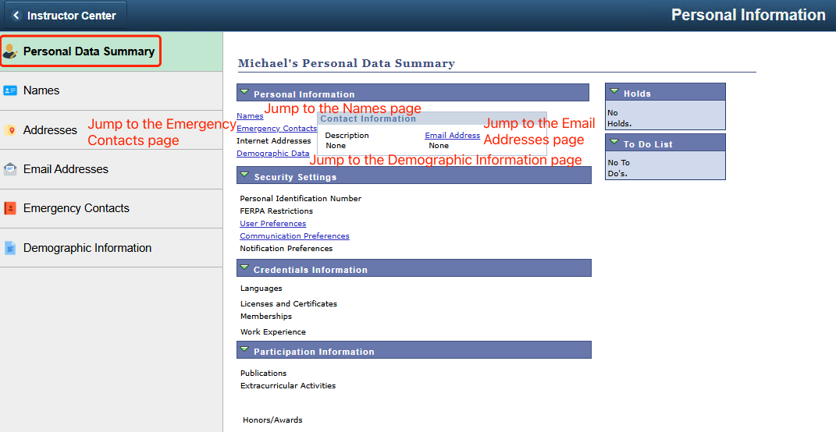
This page aggregates the access links to the personal information pages. You can click on the links to jump to the corresponding personal information pages. For the reference of the frequently used link jump information, please refer to the following figure.
Figure 4: Personal Data Summary

Viewing names
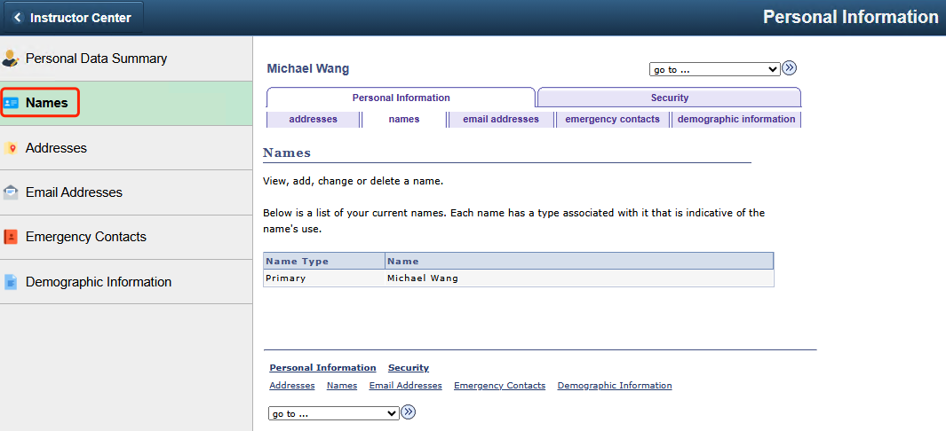
View the teacher's personal name.
Figure 5: Names

Maintaining addresses
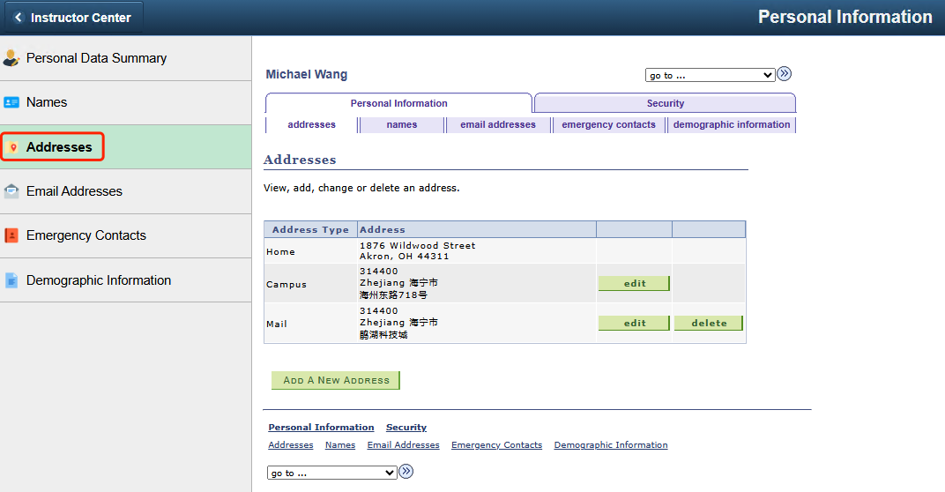
Teachers can view, add, change or delete their personal addresses information on this page.
Figure 6: Addresses

Maintaining email addresses
Teachers can view and maintain their personal email addresses on this page.
Regarding the "Preferred" checkbox: One of the email addresses must be set as "Preferred" (if there is only one email address, the "Preferred" checkbox for that email address must be checked), otherwise the page cannot be saved. When deleting an email address, the "Preferred" checkbox for that email address must be unchecked first, otherwise deletion will not be possible. In addition, the "Preferred" email address will be used as the teacher's Email Address when submitting the graduation projects (refer to the content of the Graduation Project > Submit Projects of this manual).
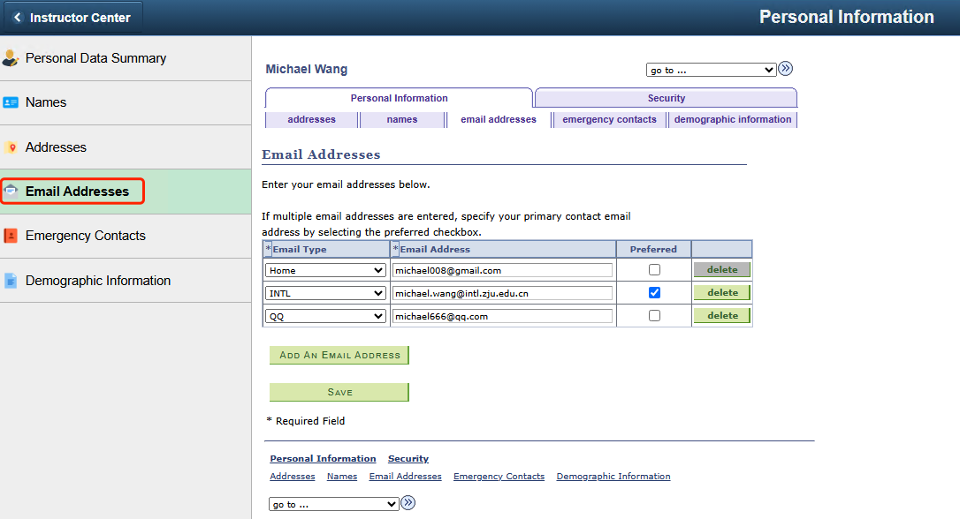
Regarding the "Email Type": The INTL type email is bound to the unified identity authentication of the campus INTL ID. It is recommended not to modify or delete it casually, otherwise it will result in the inability to log in to the system through the unified identity authentication method of the INTL ID. Teachers can maintain other types of email addresses according to their actual business needs.
Figure 7: Email Addresses

Maintaining emergency contacts
Teachers can maintain their personal emergency contact information on this page. Click the "ADD AN EMERGENCY CONTACT" button to add a new emergency contact. Enter the "Contact Name" and "Relationship". The Contact’s Address and Contact’s Phone are optional. Then click "Save".

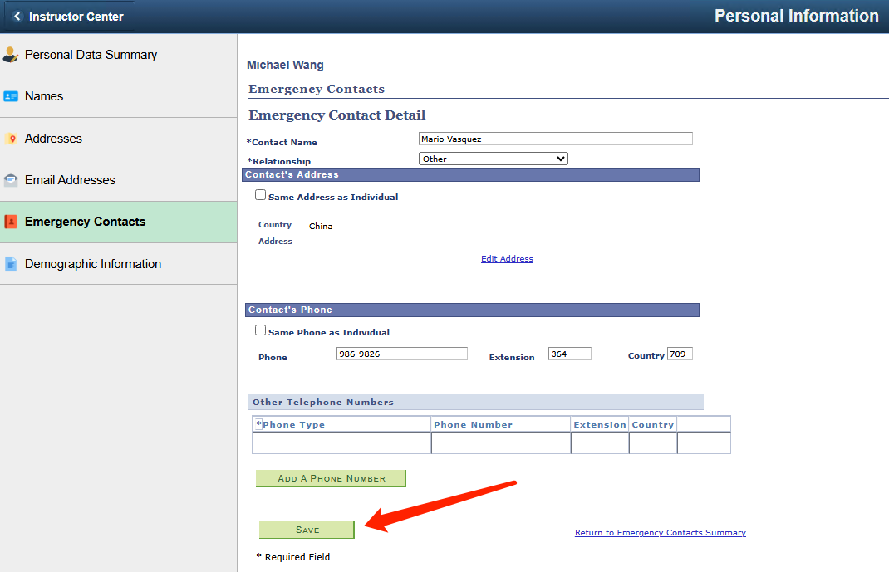
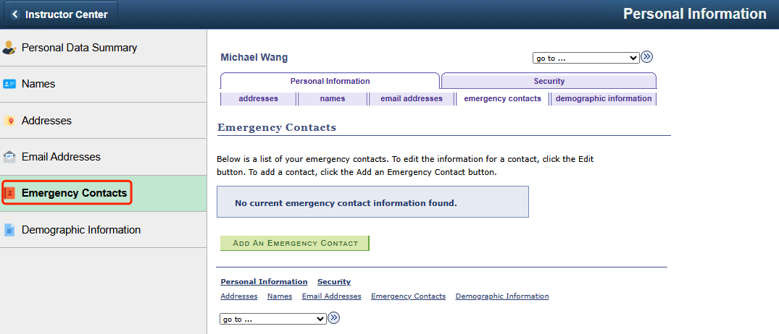
Figure 8: Emergency Contacts
Figure 9: Add an Emergency Contacts
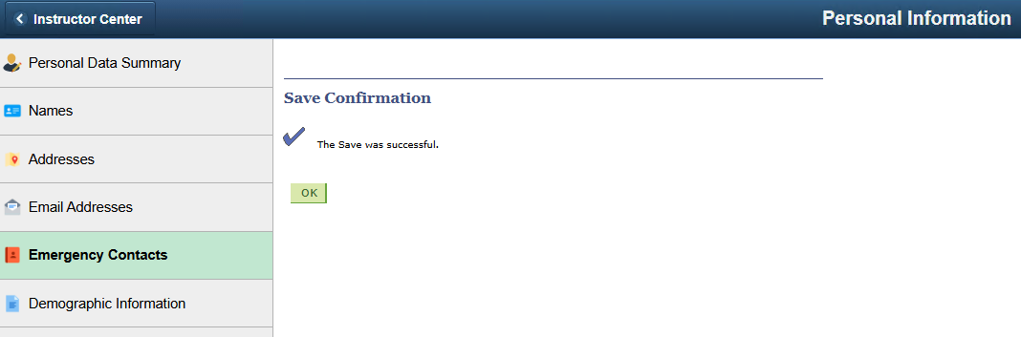
It will prompt that the saving is successful. Click "OK" to return to the Emergency Contacts Page. You can edit or delete the existing emergency contacts. When deleting, the "Primary Contact" checkbox must be in the unchecked state.
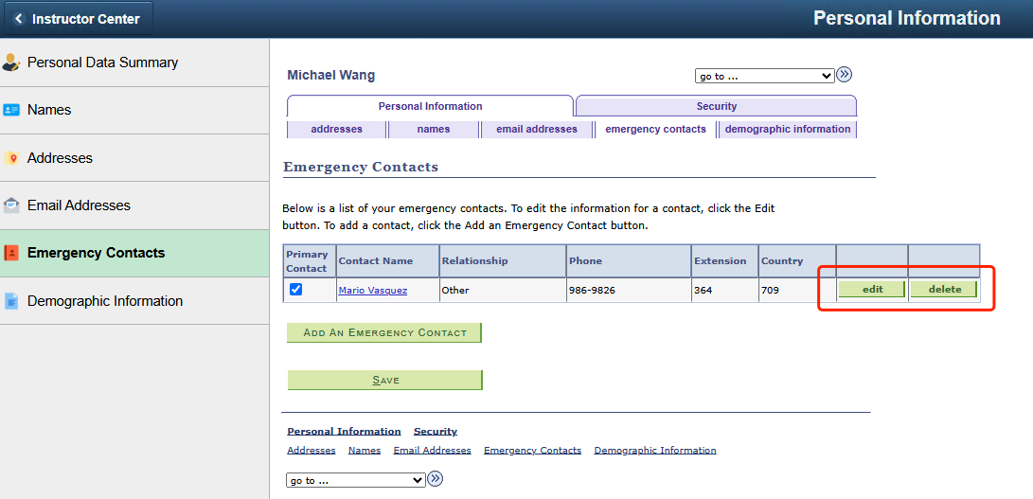
Figure 10: Emergency Contacts – Save Confirmation
Figure 11: Emergency Contacts – Edit or Delete

Viewing demographic information
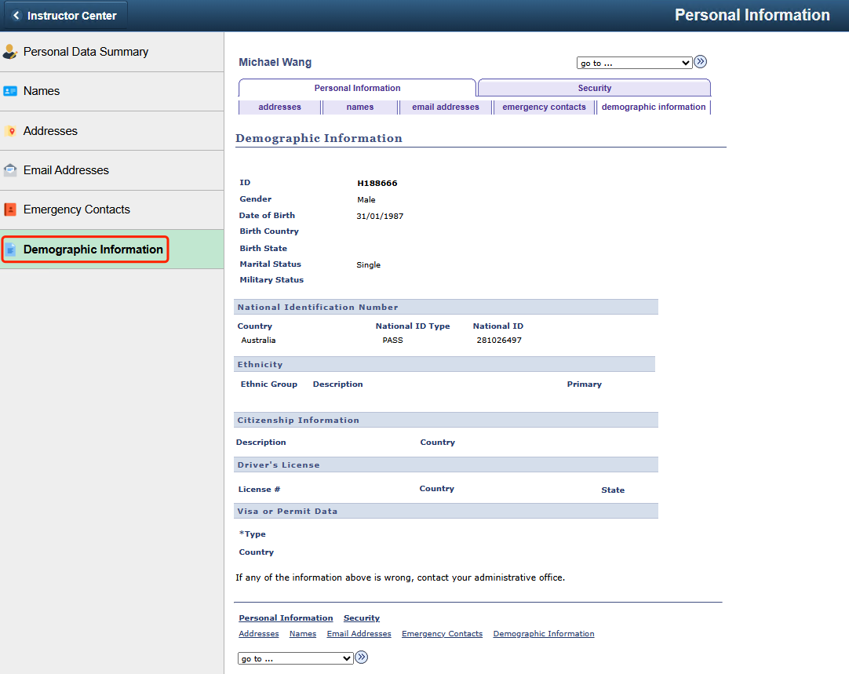
Teachers can view their other basic personal information on this page, such as Date of Birth, Marital Status, National ID type and number, etc.
Figure 12: Demographic Information

- Viewing Teaching and Exam Schedules, Class Roster and Grade Roster
As the primary instructor or teaching assistant of a class, in the Faculty Center module, teachers can view information such as the teaching classes, class rosters, class schedules, and examination schedules of their own classes. At the end of each semester, after they finish grading in Blackboard, the course grades will be automatically synchronized to PeopleSoft. Then, they can access the grade roster to view the students' final course grades. After confirming that there are no mistakes, they can download the grade report for offline signature and filing. The information of the relevant pages is summarized as follows.
Page Name | Navigation | Brief
My Schedule | Faculty Center > My Schedule | View classes and exams information
Class Roster | Faculty Center > Class Roster | View class rosters information
Grade Roster | Faculty Center > Grade Roster | View and confirm the final grades of the students in your classes

Viewing teaching and exam schedules
Click on the "My Schedule" page, under the "my schedule" tab, teachers can view the course information of their current semester. The relevant information instructions are as follows:
- Class: Course code-class identifier (class number). For example, for the course CS 50-LE1(1117), CS 50 is the course code, LE1 is the class identifier, and 1117 is the class number. You can click on the link to view the detailed information of each teaching class, including the detailed course information and the weekly class schedule in the form of a list.
- Enrolled: The number of students in the teaching class of the course.
- Days & Times: The class time of each week.
- Class Dates: The start and end date of the semester.
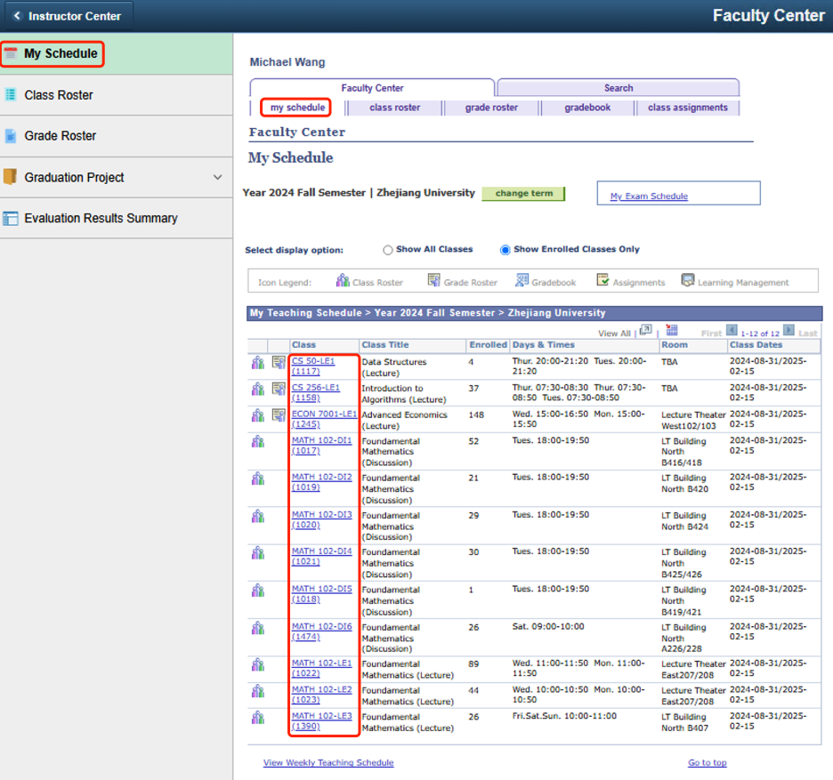
Figure 13: My Schedule

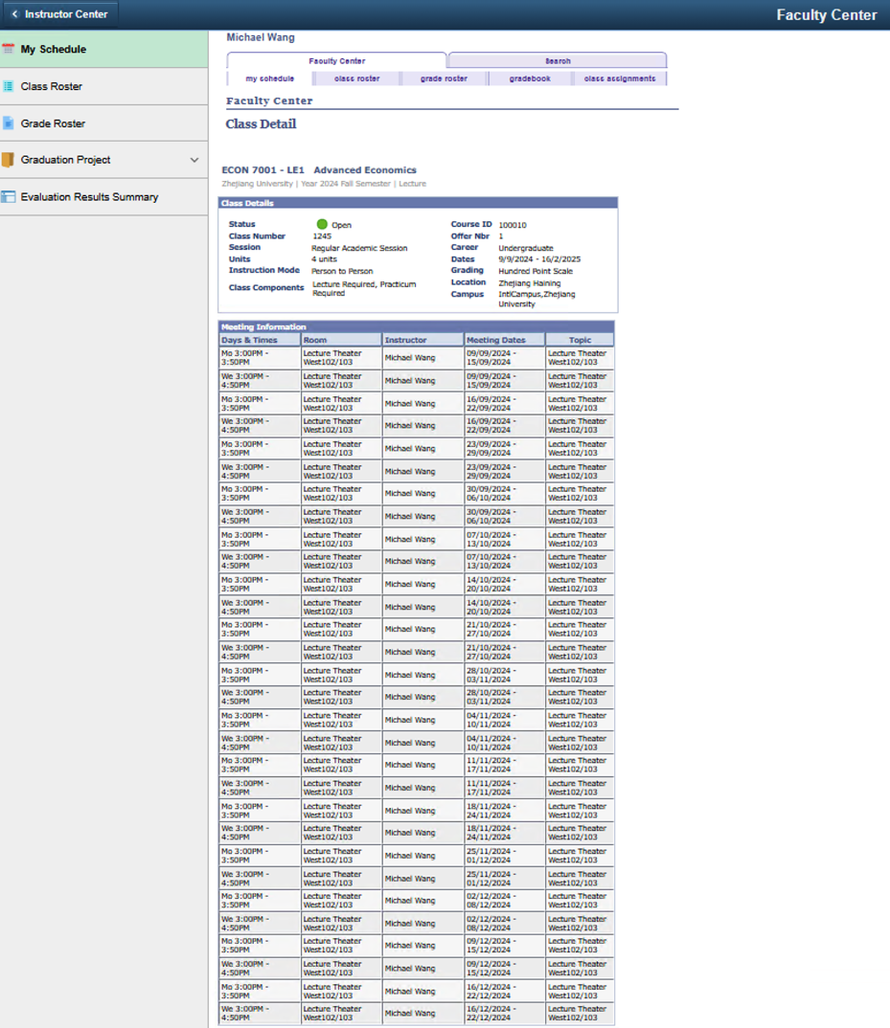
Figure 14: My Schedule-detailed information

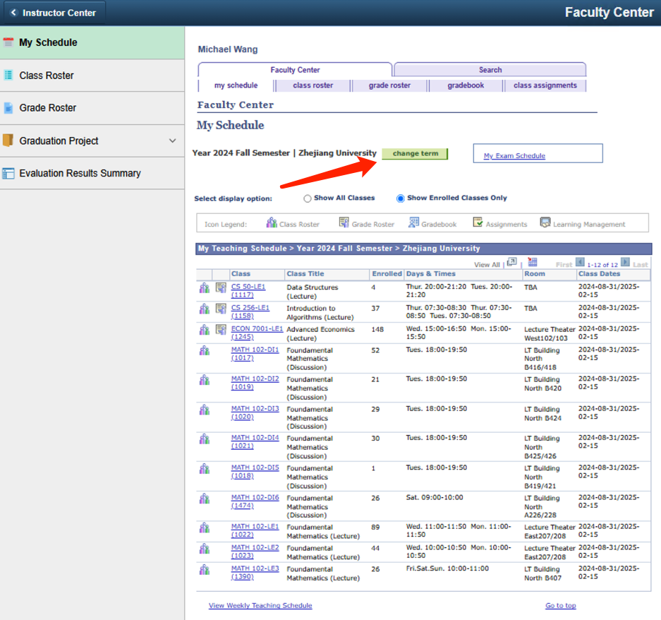
Note 1: The course information for the current semester is displayed by default. Teachers can click on "change term", then select a semester to view the course information for previous semesters.
Figure 15: My Schedule-change term

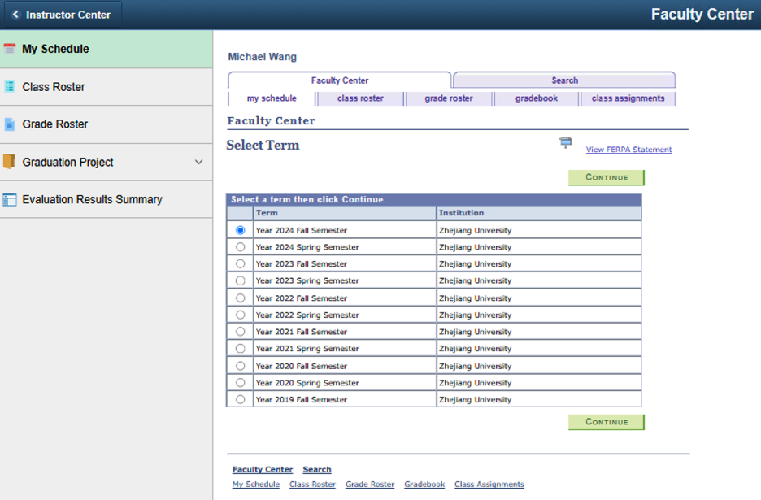
Figure 16: My Schedule-Select Term

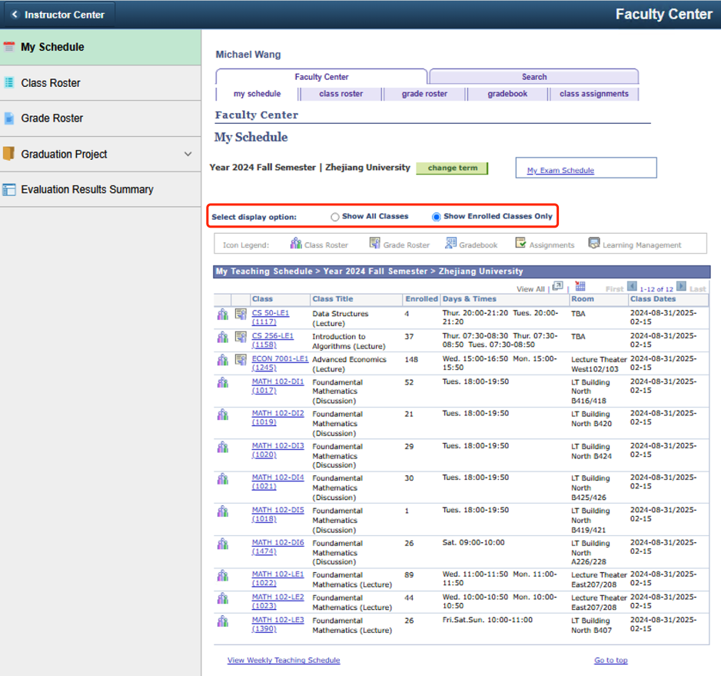
Note 2: By default, only the teaching classes with students enrolled are displayed, that is, the number of "Enrolled" students is not zero. Teachers can switch to "Show All Classes" to view all teaching classes.
Figure 17: My Schedule-Select display option

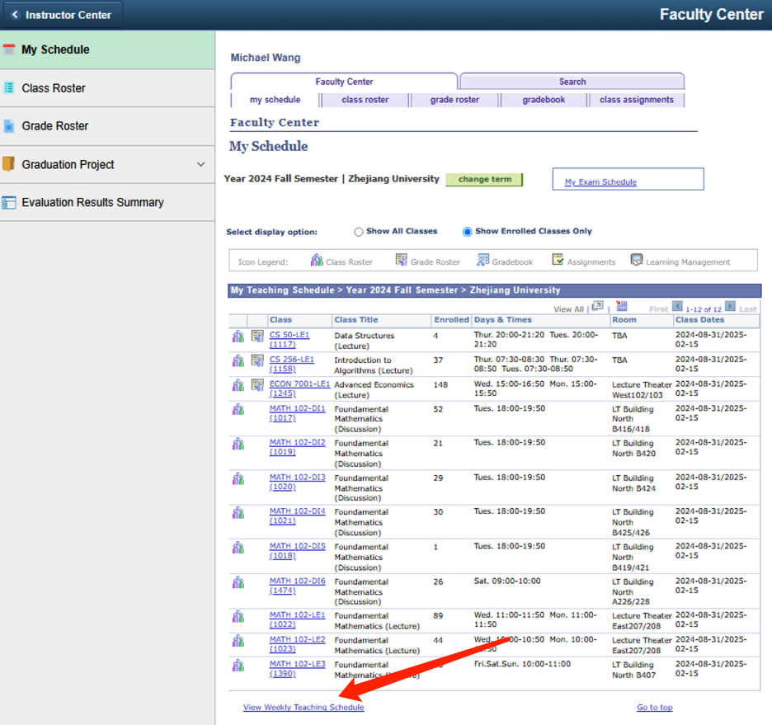
Click on "View Weekly Teaching Schedule" to view the weekly class schedule. Click on "previous week" and "next week" to switch between weekly class schedules. You can also select a specific date through "Show Week of", and then click on "refresh calendar" to jump to the class schedule of the week in which the selected date falls.
Figure 18: My Schedule-View Weekly Teaching Schedule

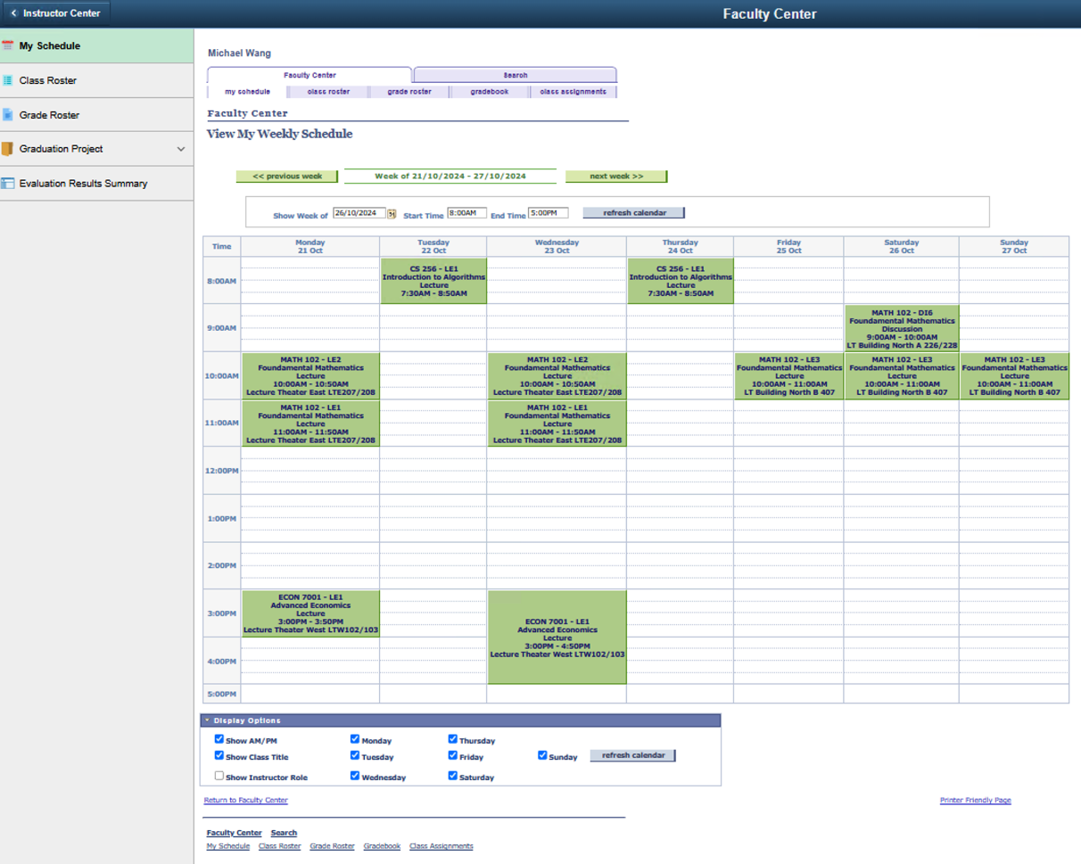
Teachers can also modify the display time range of the weekly class schedule (the default is from 8:00 AM to 8:00 PM) and the "Display Options". After making the modifications, they need to click on "refresh calendar" for the changes to take effect.
Figure 19: My Schedule-View My Weekly Schedule

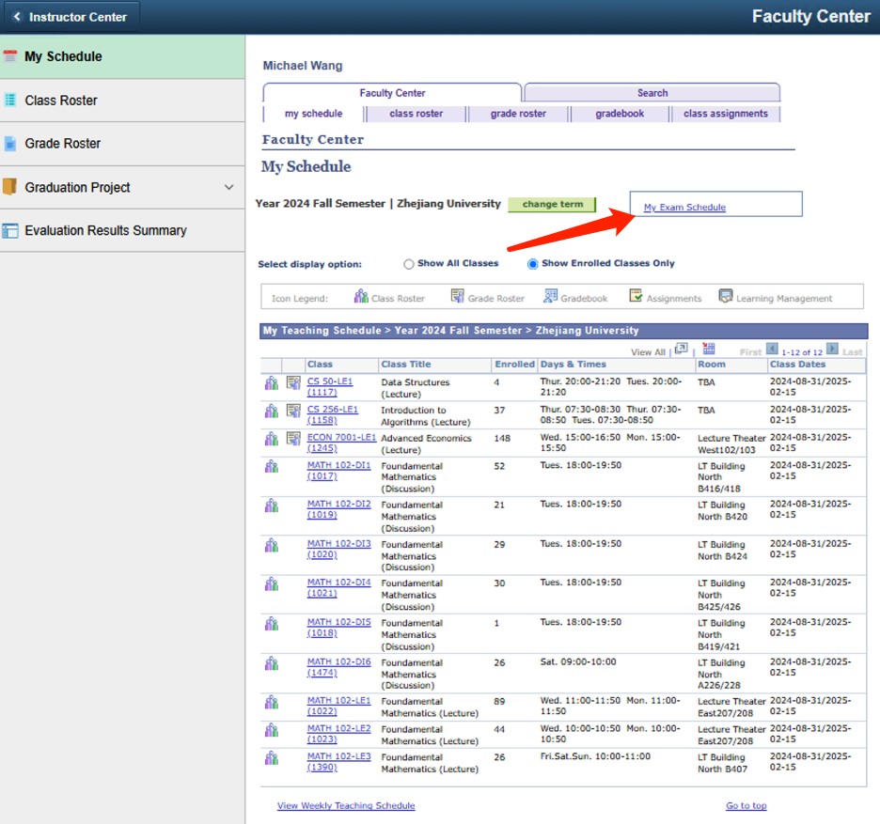
Click on "My Exam Schedule" or directly scroll the page to the bottom to view the exam schedule information of your own teaching classes, which includes the "Exam Date", "Exam Time", and "Exam Room", etc. Click on "View Weekly Exam Schedule" to view the weekly exam schedule.
Figure 20: My Schedule–My Exam Schedule

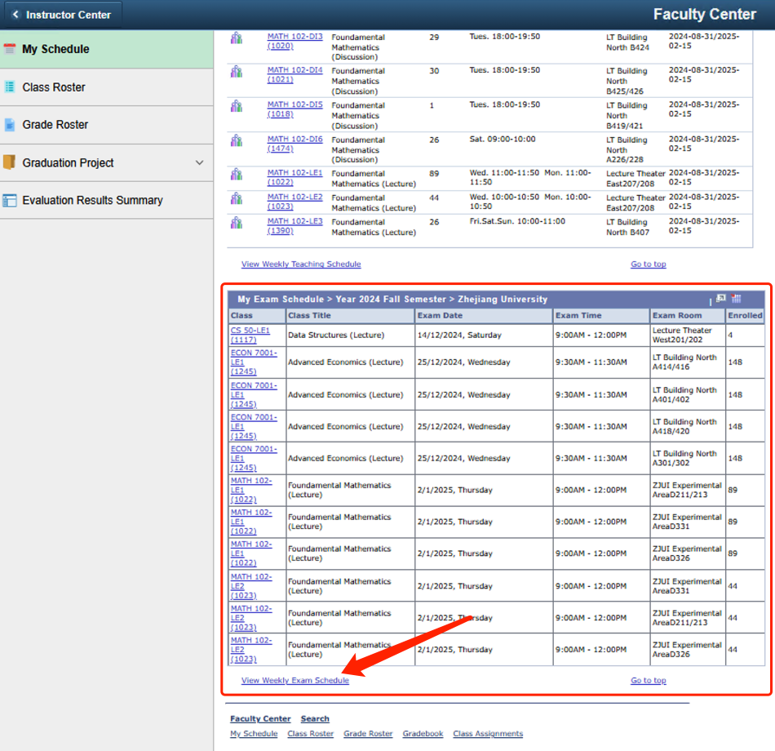
Figure 21: My Schedule - View Weekly Teaching Schedule

The functions of this page are similar to those of the "View Weekly Teaching Schedule" mentioned above, so they will not be elaborated here.
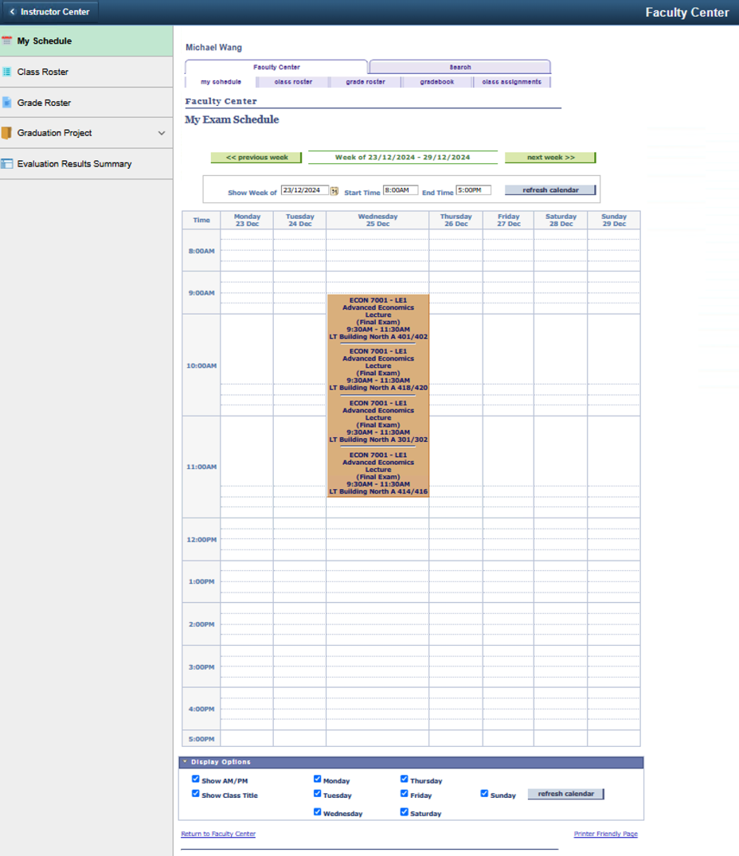
Figure 22: My Schedule-My Exam Schedule

Viewing class roster
Through the class roster, teachers can view the list of students in their teaching classes.
Click on the "Class Roster" icon to jump to the "class roster" tab and view the class roster of the teaching class.
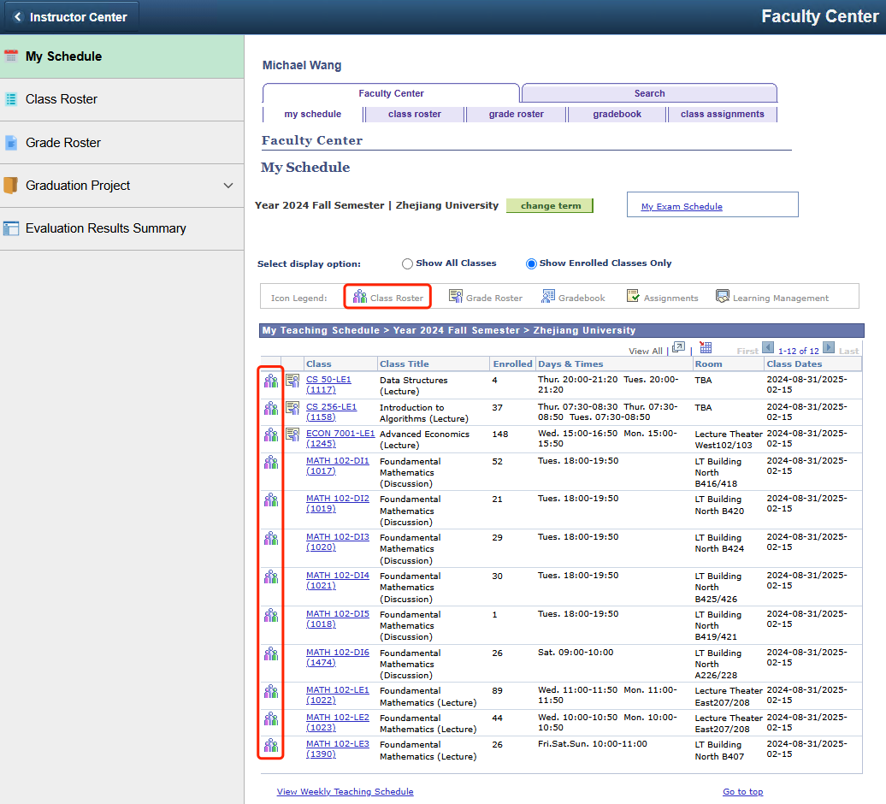
Figure 23: My Schedule-Class Roster icon
Click on the "Download " icon to download enrolled students table to excel.
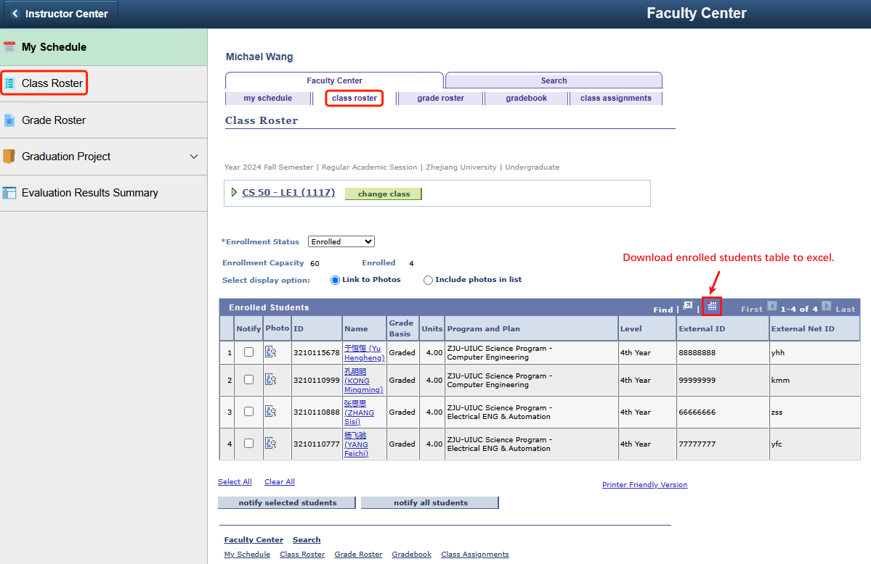
Figure 24: My Schedule-Class Roster-Download icon

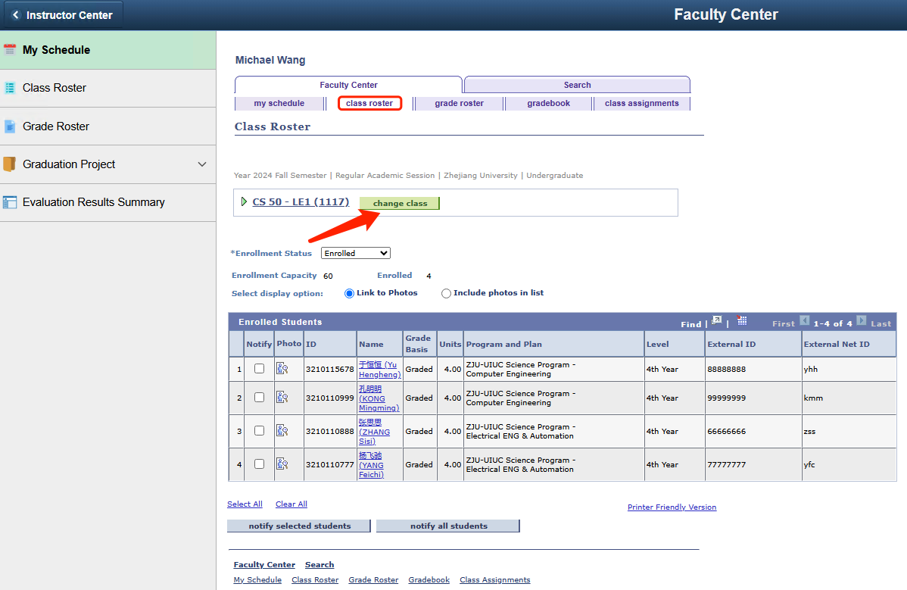
If you need to view the class roster of other teaching classes, click "change class" to return to the "my schedule" tab, and then click the icon of other teaching classes to switch.
Figure 25: My Schedule-change class

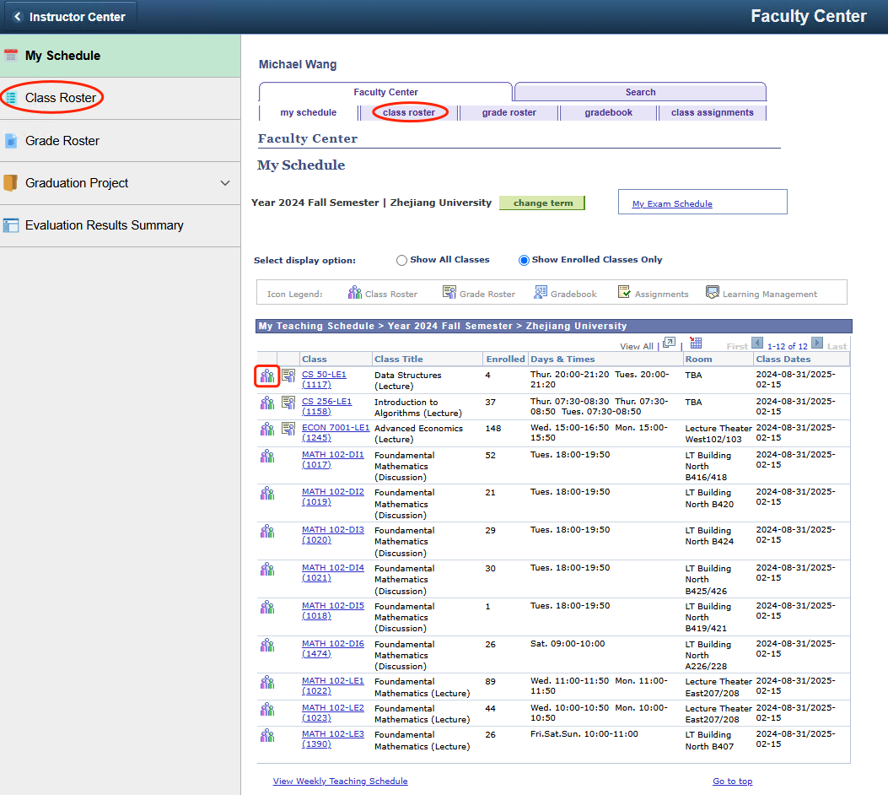
Note: After you have viewed the class roster of a certain teaching class, the system will remember the last class roster you accessed. When you click on the "Class Roster" page or the "class roster" tab again later, it will directly jump to the class roster page of that teaching class. This will only change unless you switch by clicking on the icon to view the class roster of other teaching classes.
Figure 26: My Schedule-View or Switch the Class Roster

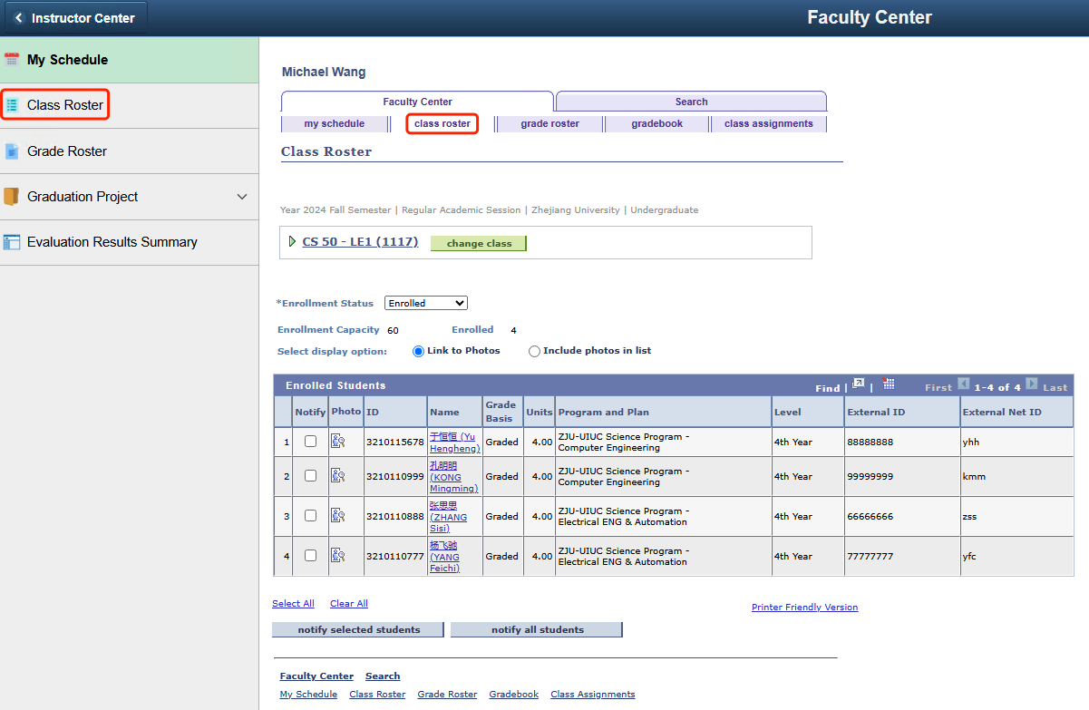
For example, if you have recently viewed the class roster of CS 50-LE1(1117), and then you directly click on the "Class Roster" page or the "class roster" tab, you will be redirected to the class roster page of CS 50-LE1(1117) again, as shown in the following figure.
Figure 27: My Schedule-Jump to the most recently accessed class roster

Viewing grade roster
Through the grade roster, teachers can view and confirm the final grades of the students in their classes.
Click on the "Grade Roster" icon to jump to the "grade roster" tab and view the grade roster of the teaching class. If the icon does not appear, it means that the grade roster for this teaching class has not been created yet. Please wait patiently.
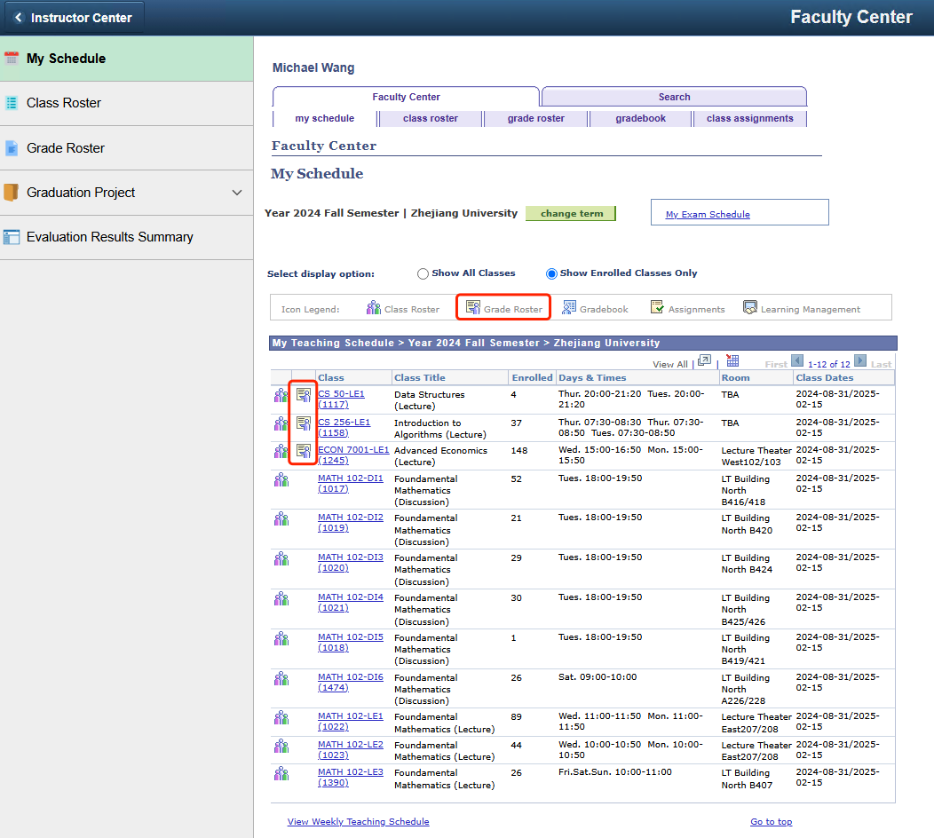 Figure 28: My Schedule-Grade Roster icon

Enter the grade roster page to view students' grade information, including "Roster Grade", "Official Grade", "Grading Basis", etc. If the grades are empty, it indicates that the final grades have not been synchronized from Blackboard to PeopleSoft yet.
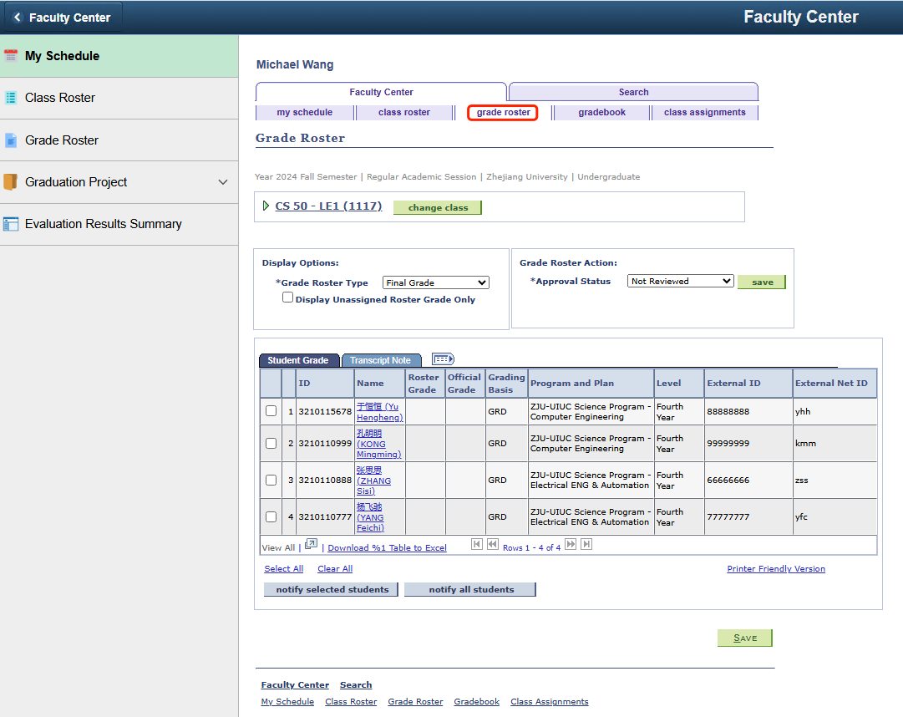
Figure 29: My Schedule-Grade Roster

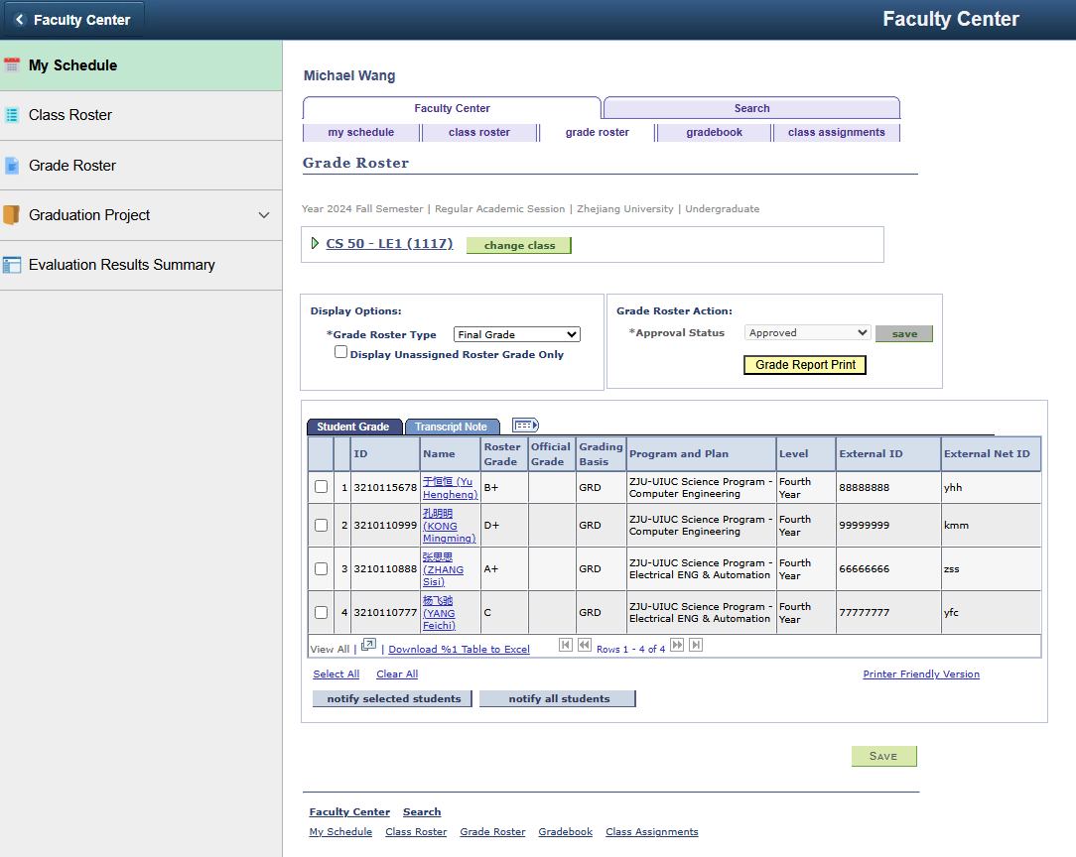
After the final grades are synchronized from Blackboard to PeopleSoft, the column of "Roster Grade" will display the students' grades, and the "Approval Status" will automatically change to "Approved". At this time, teachers can click the "Grade Report Print" button to download the grade report for offline signature and filing.
Figure 30: My Schedule-Grade Roster-Roster Grade

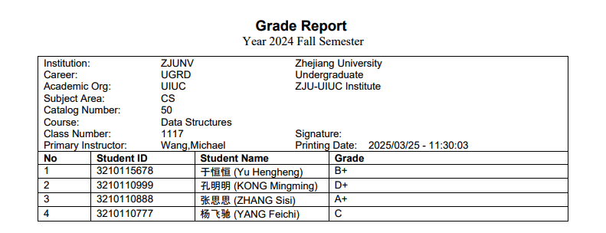
Figure 31: My Schedule-Grade Roster-Grade Report

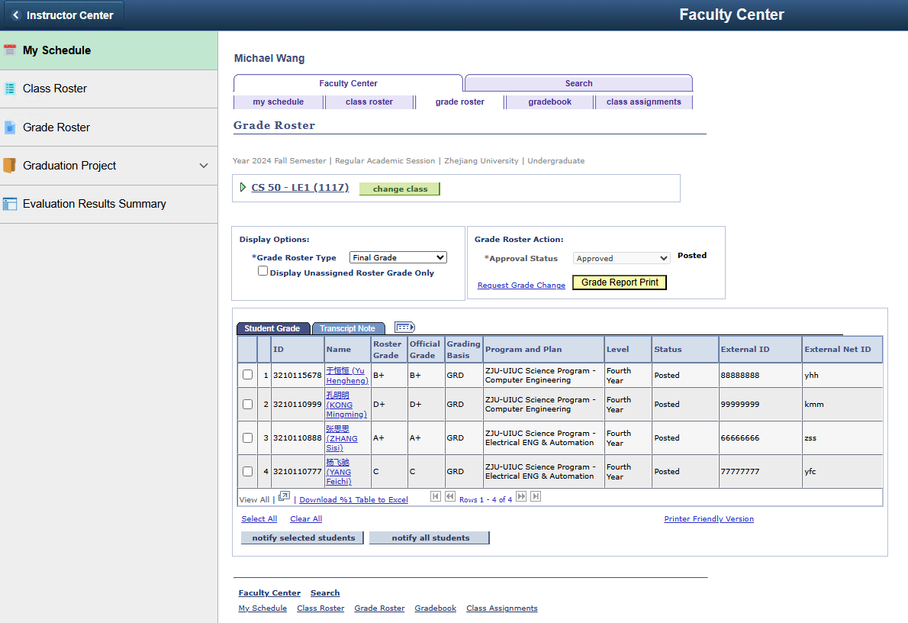
After the grades are posted, the column of "Official Grade" will display the students' official grades, and the prompt text "Posted" will appear on the right side of the "Approval Status".
Figure 32: My Schedule-Grade Roster-Offcial Grade

- Graduation Project
If a teacher serves as the supervisor of a graduation project, in the Faculty Center module, he/she can submit the graduation project, and then select the preferences submitted by students. After the selection process is completed, the teacher can view the list of students who participate in his/her graduation project in the current year. The information of the relevant pages is summarized as follows.
Page Name | Navigation | Brief
Submit Projects | Faculty Center > Graduation Project > Submit Projects | Submit and modify the graduation projects
Select My Students | Faculty Center > Graduation Project > Select My Students | Make a reverse selection of the projects preferences submitted by students
My Students | Faculty Center > Graduation Project > My Students | View the list of students who participate in the teacher’s own graduation project

Submit projects
Within the time range set by the institutes for supervisors to submit graduation project, supervisors can submit and modify the projects. Otherwise, the page cannot be edited.
Click the "Add" button to add projects, and click the button to delete projects, and click "Project ID" to view the project's detailed information.
After each modification, you need to click the "OK" button at the bottom to save the changes.
Note 1: The "Email Address" displayed in the project is the email marked as "Preferred" on the "Personal Information > Email Address" page.
Note 2: Since the selection and match process for graduation projects generally lasts for one academic year, the graduation project process is identified based on the starting semester of the graduation project business (the Term code at the top of the page).
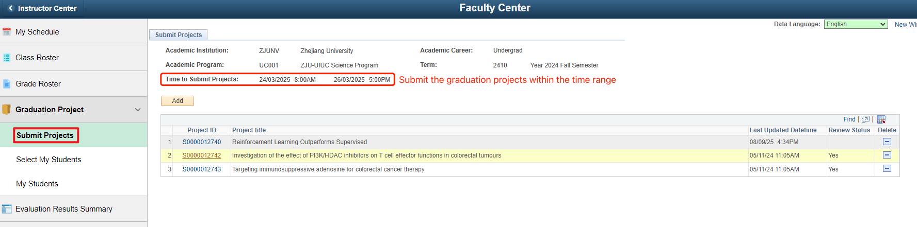Figure 33: Graduation Project-Submit Projects-Time Range

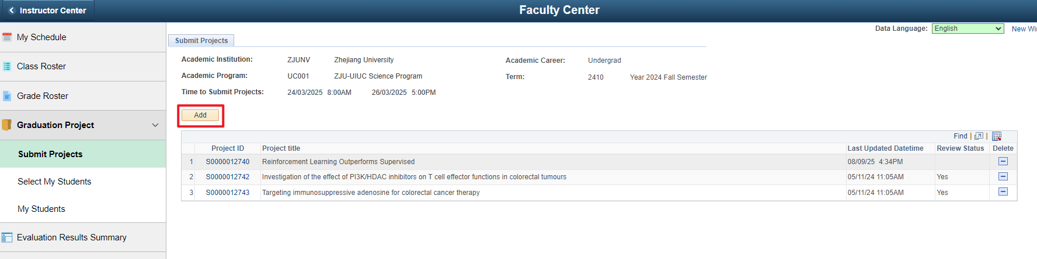
Figure 34: Graduation Project-Submit Projects-Add projects
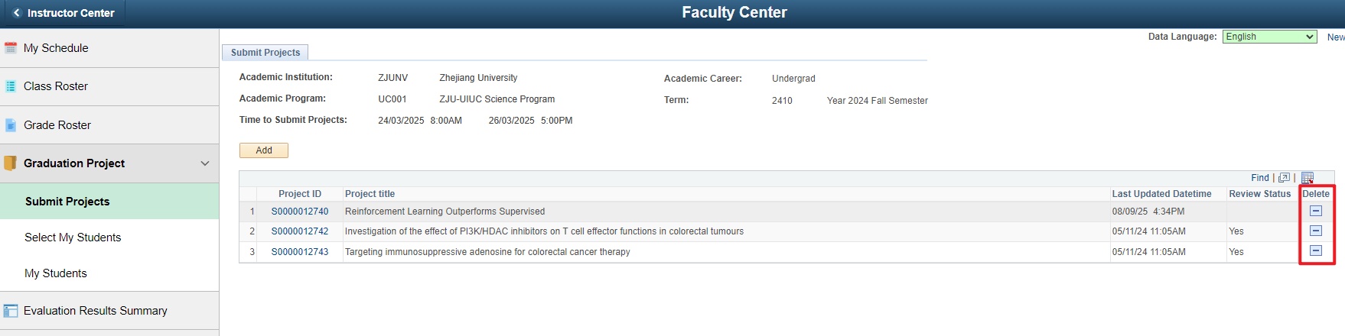
Figure 35: Graduation Project-Submit Projects-Delete projects

Note 3: If you need to upload ethical approvals, please "Submit" first for creating the project, then "Add" and upload, and don't forget to "Submit" again. (You can only upload one file. So if you have more than one approvals, you can compile them in one .ZIP file. You can also click "Delete" and upload again to update.)
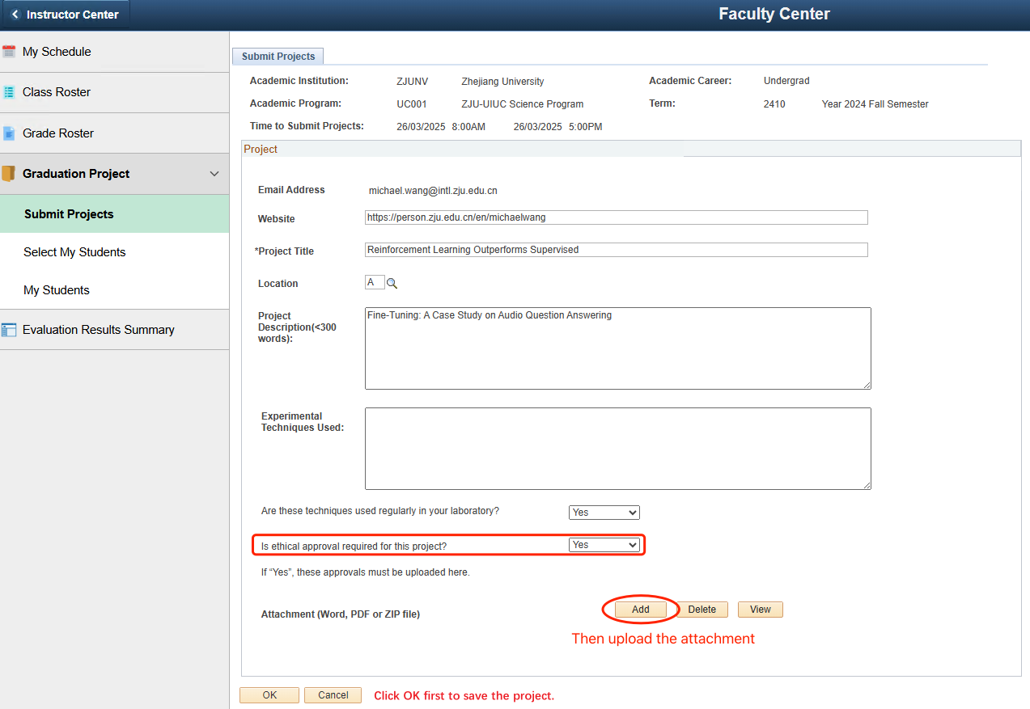
Figure 36: Graduation Project-echical approvals

After the deadline for projects submission, the institute will review the graduation projects. If a project passes the review, the "Review Status" in the upper right corner of the project will display "Yes"; if it fails the review, it will display "No". The projects that have passed the review will then enter the projects selection process for the graduation project.
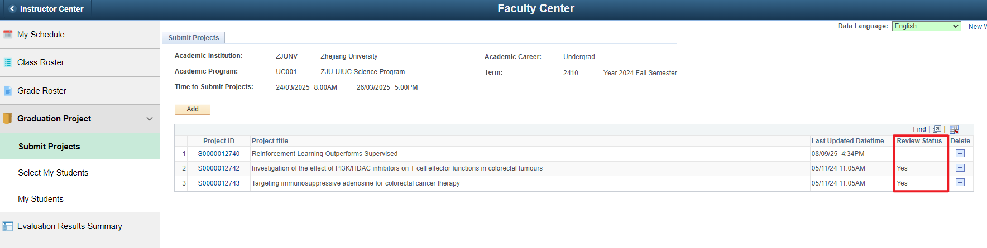
Figure 37-1: Graduation Project-Submit Projects-Review Status
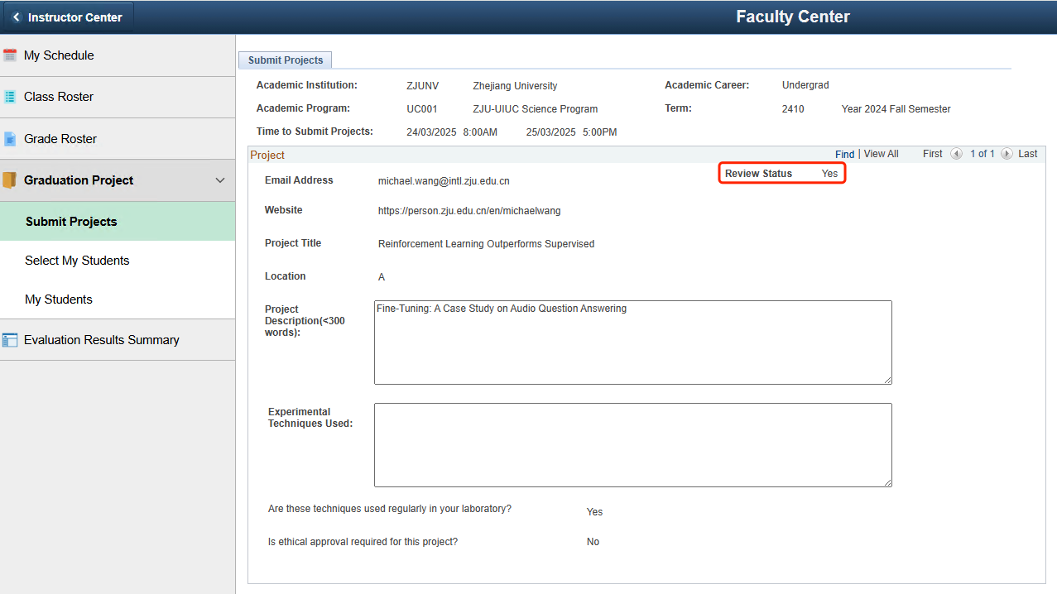
Figure 37-2: Graduation Project-Submit Projects-Review Status

Select my students
The graduation projects will first be opened for students to choose from. If the list of students is empty, it means that no student has selected your project. After the students have finished choosing their supervisors and topics, within the time range for "Time to Choose Students", supervisors can choose "Agree" or "Disagree" from the "Mentor Choose Status" dropdown menu to decide whether to make a reverse selection of the students' preferences, then click "Submit" to save. Otherwise, the page cannot be edited.
Note: The college may initiate multiple rounds of project mutual selection process based on actual needs. Students who failed to secure a match in the previous round may resubmit their project preferences, and supervisors may conduct another round of reverse selection. However, records of already matched project mutual selection result cannot be modified.
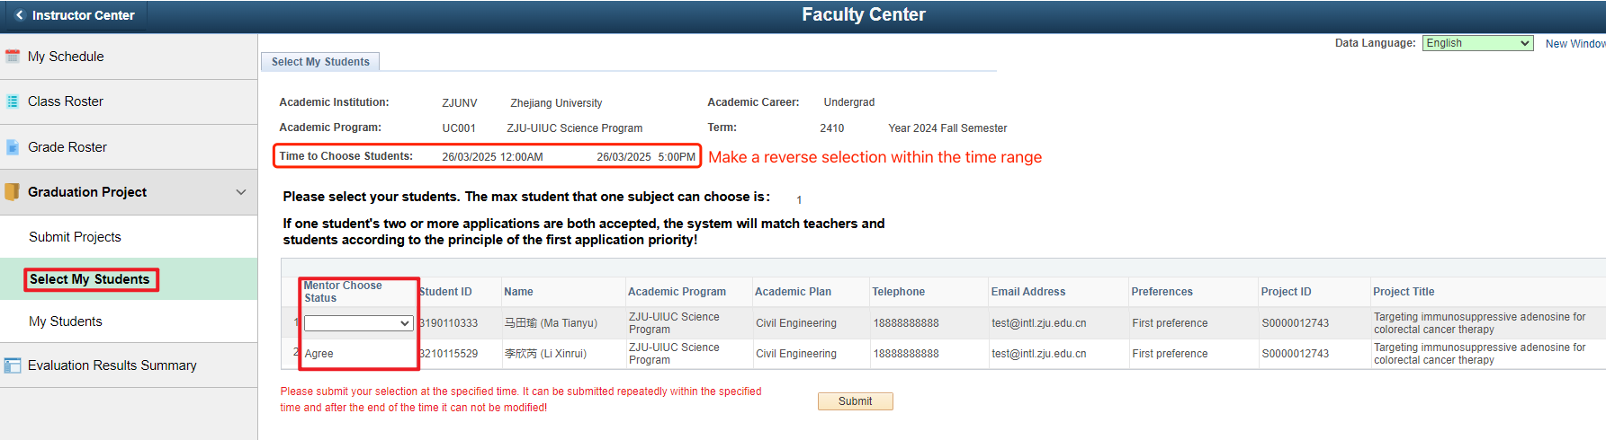Figure 38: Graduation Project-Select My Students–student’s preferences reverse-selection

View my students
After the selection process for the graduation project is completed, supervisors can view the information of the students who have been matched with their graduation projects, and they can also view previous records (if any). Instructors can search students by academic career, academic program, and term(2310 means Fall/Winter 23-24 semester, 2410 means Fall/Winter 24-25 semester, and so on) .As shown in the figure below, search for the graduation project processes related to oneself, and then click on the current graduation project process to view the details.
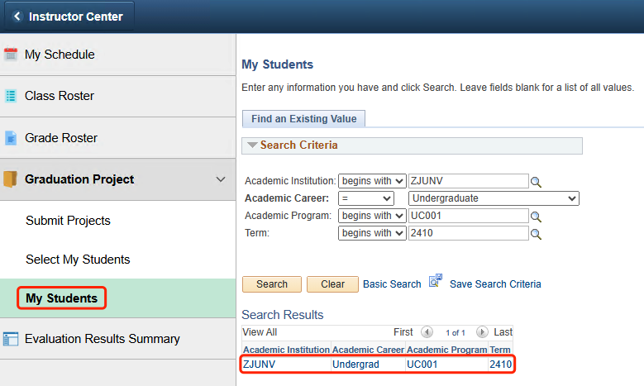
Figure 39: Graduation Project-My Students

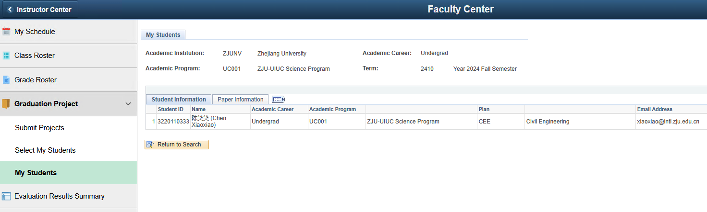
Figure 40: Graduation Project-My Students-Student Information
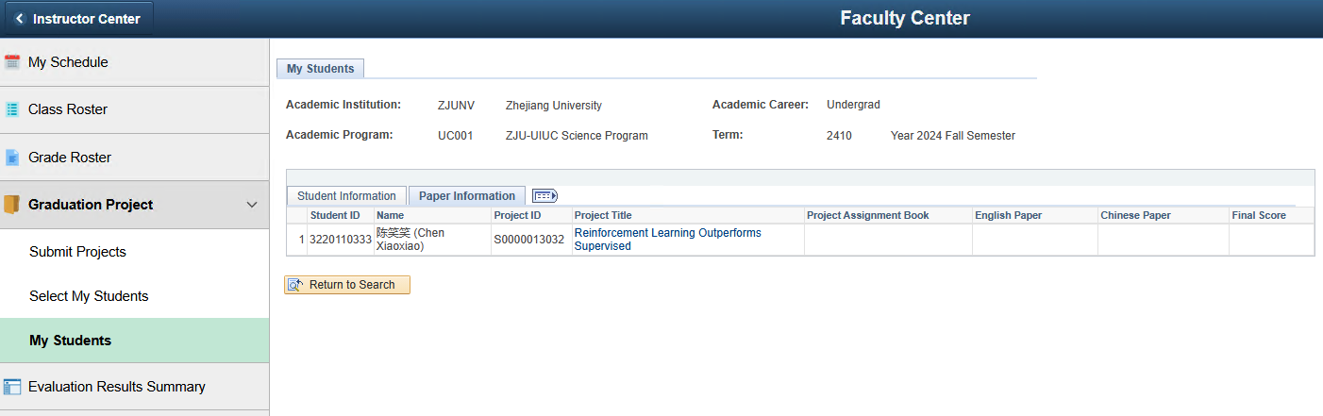
Figure 41: Graduation Project-My Students-Paper Information

- Viewing Evaluation Results Summary
According to the course evaluation requirements for each semester, if it is an evaluation of the teaching faculty, after the student evaluation is completed and the results are released, as a teaching teacher, one can view the evaluation summary information related to oneself, or click on "Download PDF Report" to download the evaluation report and view the detailed evaluation information. The information of the relevant pages is summarized as follows.
Page Name | Navigation | Brief
Evaluation Results Summary | Faculty Center > Evaluation Results Summary | View the teaching evaluation summary information and the teaching evaluation report of the teacher

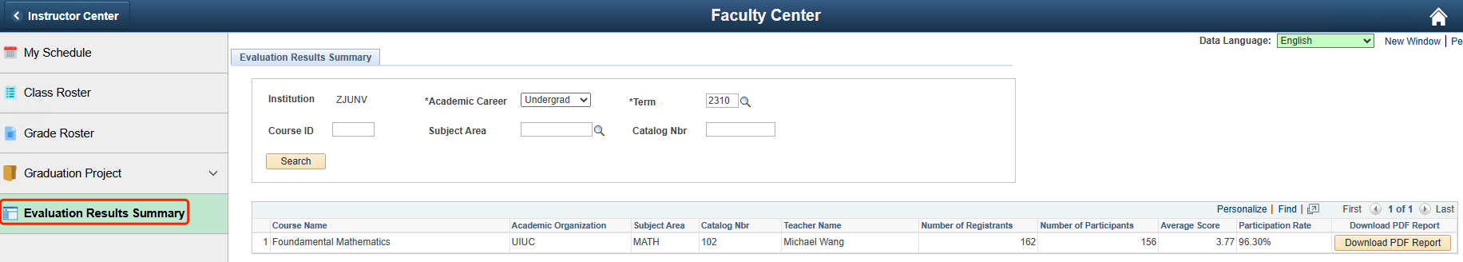
Figure 42: Evaluation Results Summary
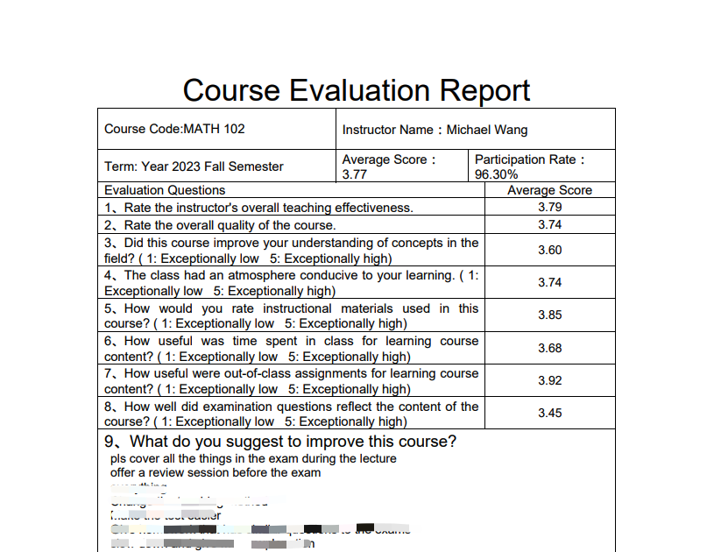
Figure 43: Evaluation Results Summary-PDF Report

If you have any questions or requirements regarding the content of the manual, please feel free to contact the campus Information Technology Services (ITS) at any time.
Hotline: 0571-87572669
Email: itservices@intl.zju.edu.cn

Walk-in: Library 1st Floor

